|  |
| --- |
| http://josetinoco.com |
| “Super Slot Machine” |
| **Game documentation** |
| Version 1.0  All work (except images and sounds) copyright © 2016 by Joseph Tinoco.  All rights reserved.  Uses visual and sound elements © Nintendo Inc. (please don’t sue me) |
| **Joseph Tinoco** |
|  |

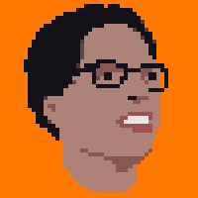

|  |
| --- |
| Feb 26th 2016 |

Contents

I. Game Overview 4

II. Game Play Mechanics 4

III. Interface Sketch 4

IV. Menu and Screen Descriptions 5

V. Scoring 6

VI. Sound Index 7

VII. Art / Multimedia Index 7

VIII. Design Notes 8

**Version History**

V1.0 – Final version, for submission. Feb 26, 2015

# Game Overview

This game is a simple slot machine implementation. As in the real version, the goal of the game is to win money by betting in combinations of figures on the machine’s reels.

The game aesthetics has a “8-bit Mario” theme: the reels display pixelated elements from the classic games, the sound effects are extracted from old Mario games, and so on.

# Game Play Mechanics

* The game gives 30 credits for the player as starting money.
* To spin the reels, the player must place a bet of 1, 2 or 3 credits. The bet amount influences the earnings: a bet of 2 credits doubles the payouts, while a bet of 3 triples the payout.
* After placing a bet, the player can click the “spin” button to spin the wheels and get a random combination of figures on the *bet line* (the center portion of all reels).
* The bet line result is scored against the payout table, with a multiplier applied according to the number of credits of the player’s bet, e.g, a result of two coins pays 5 credits for a bet of 1 credit, 10 credits for a bet of 2 credits, and 15 credits for a bet of 3 credits.
* If the player runs out of money, the game is over: the player cannot bet or spin the wheel anymore. It is possible to restart the game, though, by clicking on the “Reset” button.
* The “Quit” button finishes the game instantly and displays a “thank you” message.

# Interface Sketch

The screenshot below describes the main interface elements.

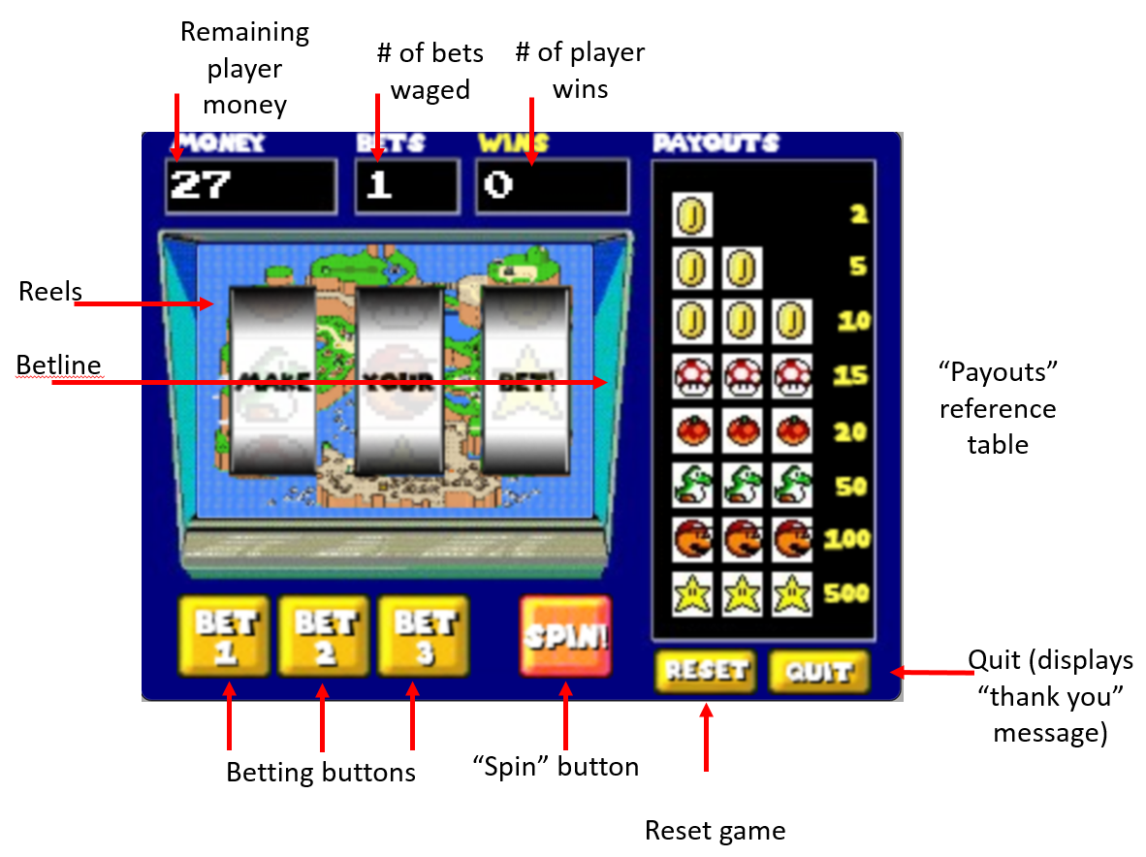

The buttons to place a bet, spin the reels, quit and reset the game can be operated by mouse clicks or finger taps in touch-enabled devices.

# Menu and Screen Descriptions

The game presents an initial screen when first loaded, shown below. A click/tap on the “Play” game starts the game.

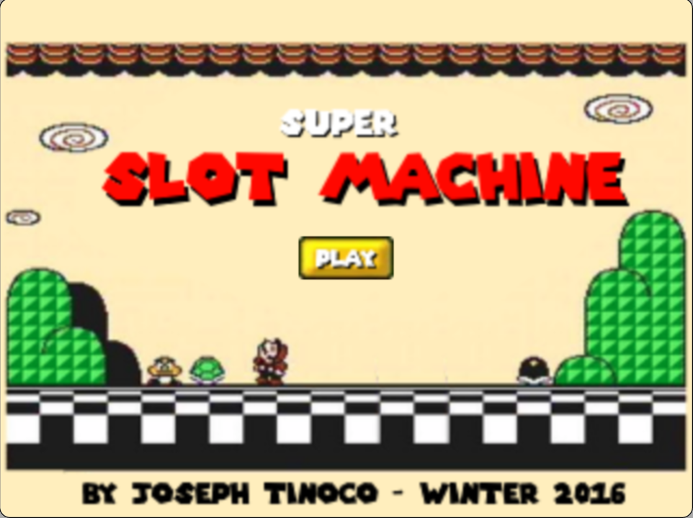

After playing, if the player quits the game, the “thank you” screen (below) is shown.

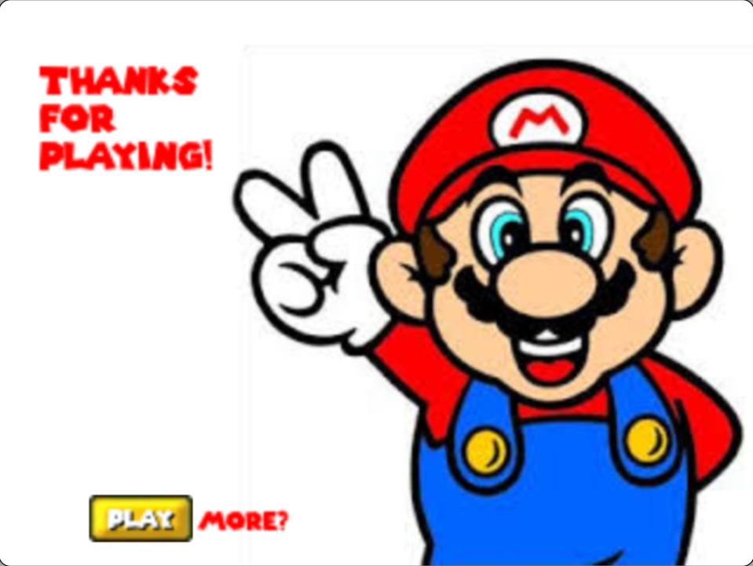

# Scoring

The complete version of the payout table is shown below:

|  |  |  |  |
| --- | --- | --- | --- |
|  | Betting 1 credit | Betting 2 credits | Betting 3 credits |
| One coin (any position) | 2 | 4 | 6 |
| Two coins (any position) | 5 | 10 | 15 |
| Three coins | 10 | 20 | 30 |
| Three mushrooms | 15 | 30 | 45 |
| Three fruits | 20 | 40 | 60 |
| Three Yoshis | 50 | 100 | 200 |
| Three Marios | 100 | 200 | 300 |
| Three Stars | 500 | 1000 | 1500 |

The three star, 3 credits bet result (1500 credits) is the game’s **jackpot**. The game plays a special music when the player scores a jackpot.

# Sound Index

|  |  |  |
| --- | --- | --- |
| Asset name | Description | File name |
| StartSound | The initial sound played at the startup screen. | Start.wav |
| SpinningSound | The sound the reels make when they spin | Spinning.wav |
| StoppingSound | The sound a reel makes when it stops spinning | Stopping.wav |
| BetButtonSound | Played after the user clicks one of the bet buttons. | Betbutton.wav |
| JackpotSound | A special music played when the user gets a jackpot. | Jackpot.wav |
| WinSound | Played when the user wins anything less than 20 credits. | Win.wav |
| BigWinSound | Played when the user wins anything more than 20 credits, but less than the jackpot. | Bigwin.wav |
| LoseSound | Played when the user does not win anything in a wager. | Lose.wav |
| GoodbyeSound | Played when the user clicks “quit”. | Goodbye.wav |

# Art / Multimedia Index

The graphic elements used to build the slot machine are shown below.

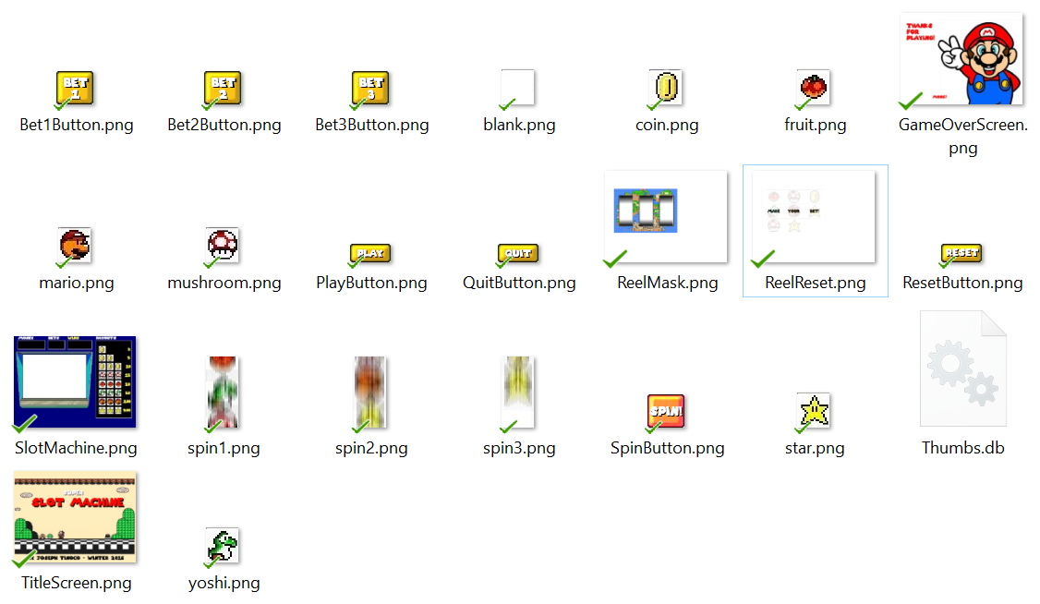

Notes about the image assets:

* “Spin1”, “Spin2” and “Spin3” are the frames of the spin turning animation.
* The slot machine is built on screen in the following order:
  1. **SlotMachine.png** (the base)
  2. **ReelReset.png** (the initial status of the reels when the player starts the game. It only displays a “make your bet” message).
  3. **Nine result images** shown in three lines on the machine “screen”, or frames of the reel spin animation.
  4. **ReelMask.png**, covering the reels to give it a “round” effect and partially cover the non-betting lines.
  5. Finally, the **labels** for player money, wins and bets are updated.

# Design Notes

To achieve the “8-bit” look and feel, the entire game was designed at the resolution of 320x200, and the entire viewport is scaled to twice its original size when displaying the game.